# Caremark.com Alert Examples

Prescription Overdue for Refill

Prescription Refill Available

Order Placed on Hold

Cannot Fill

No Response from Prescriber

Refill to Soon

Order Processing Date changed

Order Confirmation

Order Received

Order Shipped Confirmation

Member Registration

Participant Hold

Multifactor Verification Code Request

Password Changed (Forgot Password)

Username Retrieved (Forgot Username)

Refill Available Alert

Prescription about to Expire / Expired-Renew Rx

Automatic Refill In Progress

Prescription Removed from Auto Refill/Renewal

Enrolling in Automatic Refills

Rx Savings Opportunities

Shipping Delay Confirmation

Zero Refills Remain

Related Document

**Description:** This document contains Caremark Alert examples and should be utilized with the related document.

**Note:**  Screen captures may not match actual scenario for this process. Some clients may not enlist in specific web features. This work instruction/job aid is intended as a guide only.

|  |
| --- |
| Prescription Overdue for Refill |

**Prescription Overdue for Refill Alert Example:**

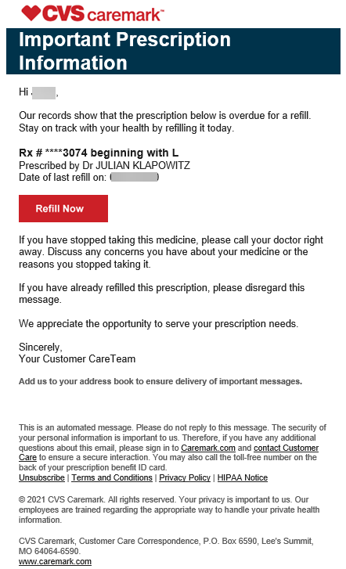

Top of the Document

|  |
| --- |
| Prescription Refill Available |

**Prescription Refill Available Example:**

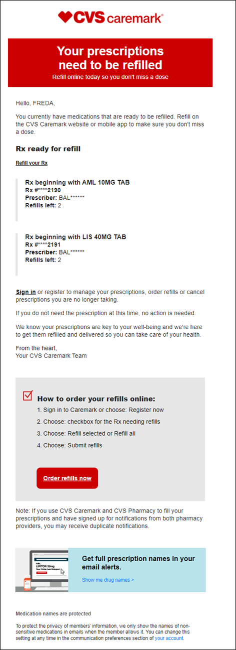

Top of the Document

|  |
| --- |
| Order Placed on Hold |

**Order Placed on Hold Examples:**

**Med-D Ship Consent – Initial Alert**

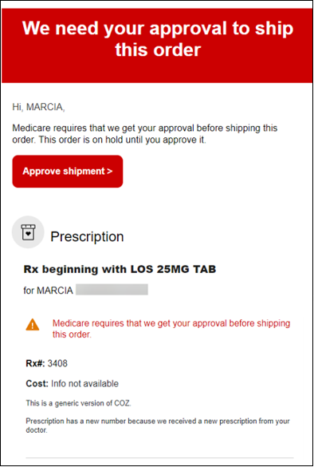

**Med-D Ship Consent Reminder Alert**

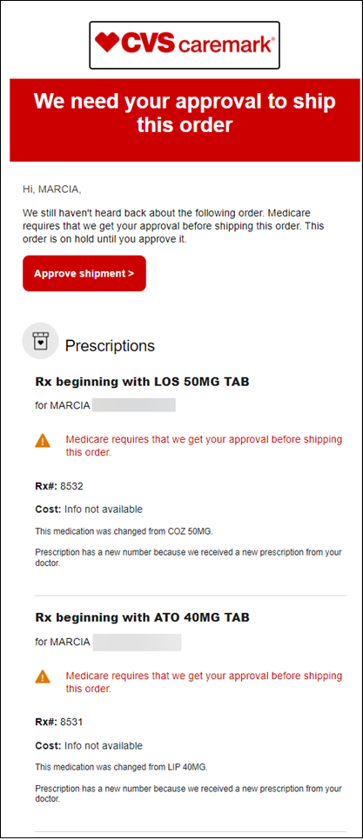

**Med-D Ship Consent Not Received/ Automatic Refills on Hold**

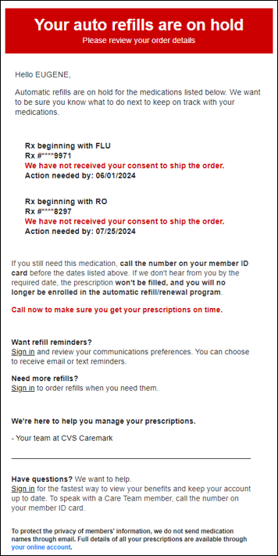

**Consent to Pay / High Copay**

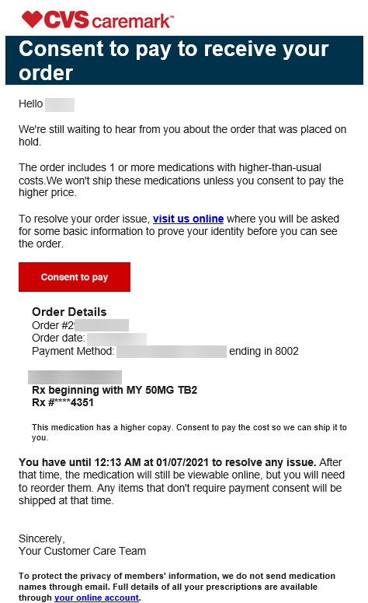

Top of the Document

|  |
| --- |
| Cannot Fill |

**Cannot fill Examples:**

**Drug Not Available**

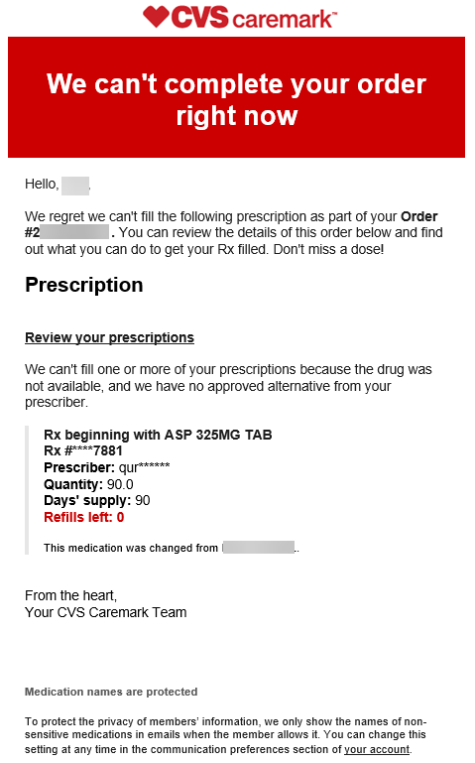

**Payment Issue**

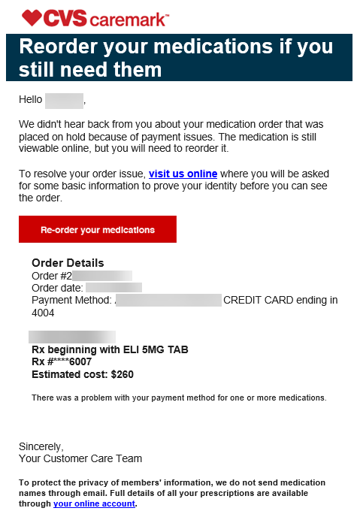

Top of the Document

|  |
| --- |
| No Response from Prescriber |

**No Response from Prescriber Example:**

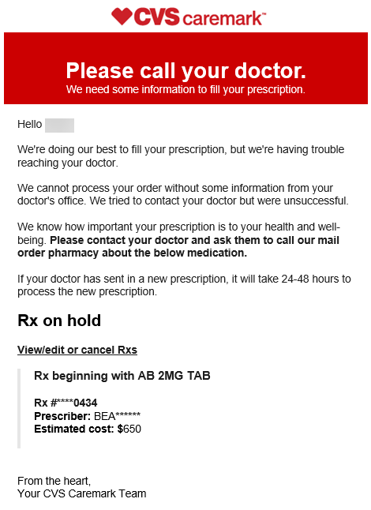

Top of the Document

|  |
| --- |
| Refill to Soon |

**Refill to Soon Example:**

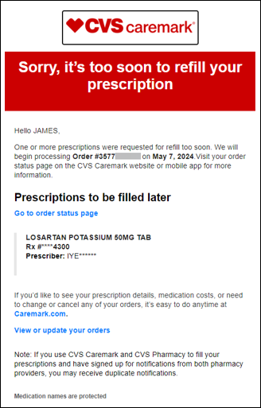

Top of the Document

|  |
| --- |
| Order Processing Date changed |

**Order Processing Date Changed Example:**

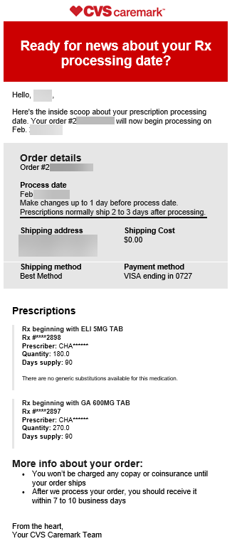

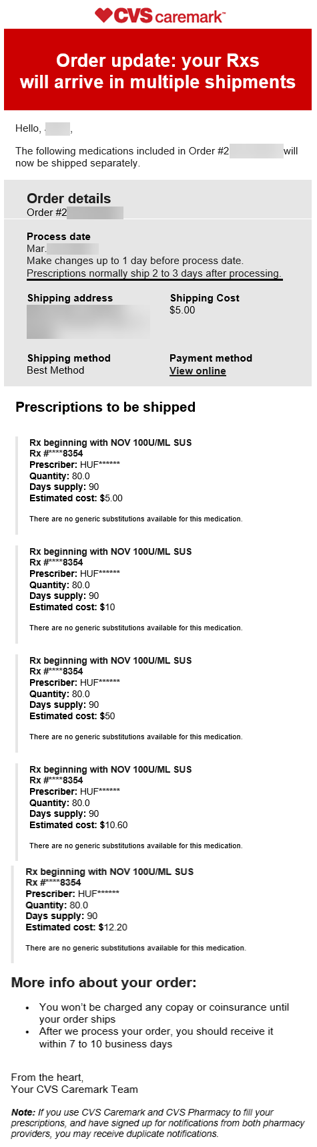

Top of the Document

|  |
| --- |
| Order Confirmation |

**Order Confirmation Example:**

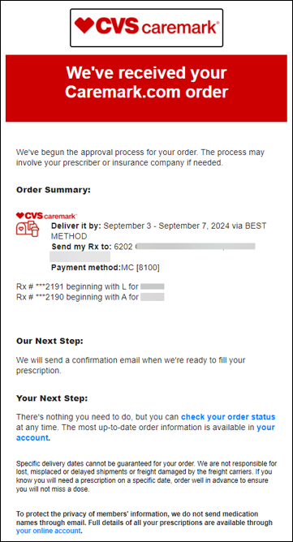

Top of the Document

|  |
| --- |
| Order Received |

**Order Received Example:**

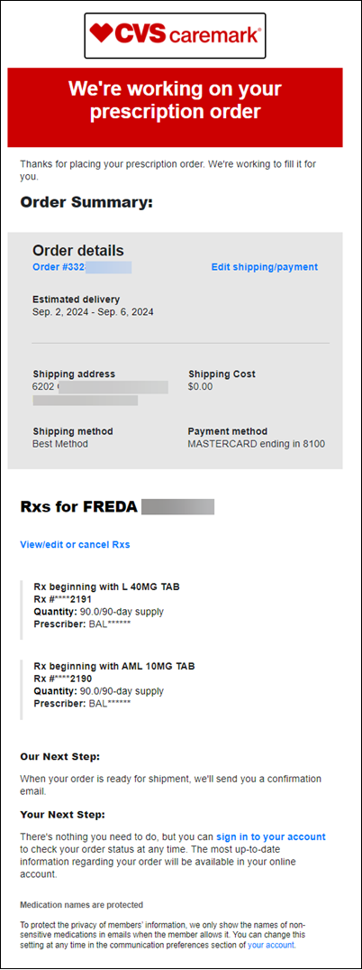

Top of the Document

|  |
| --- |
| Order Shipped Confirmation |

**Order Shipped Examples:**

**Order Shipped (1 Order)**

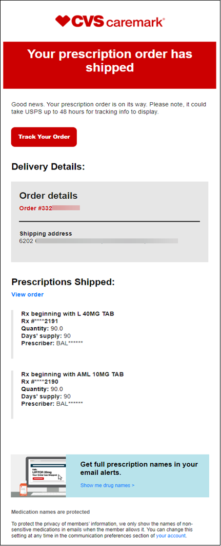

**More than 1 Order Shipped / Combined**

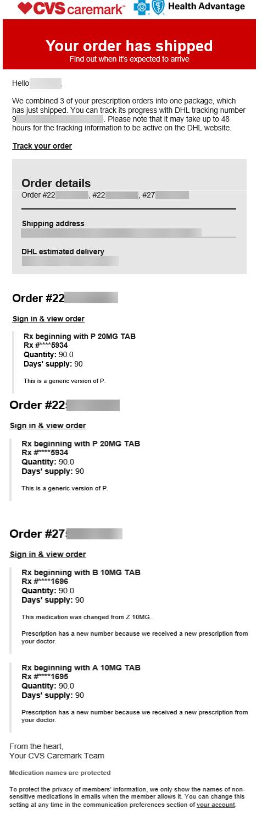

Top of the Document

|  |
| --- |
| Member Registration |

**Caremark.com Registration Examples:**

**Quick Registration**

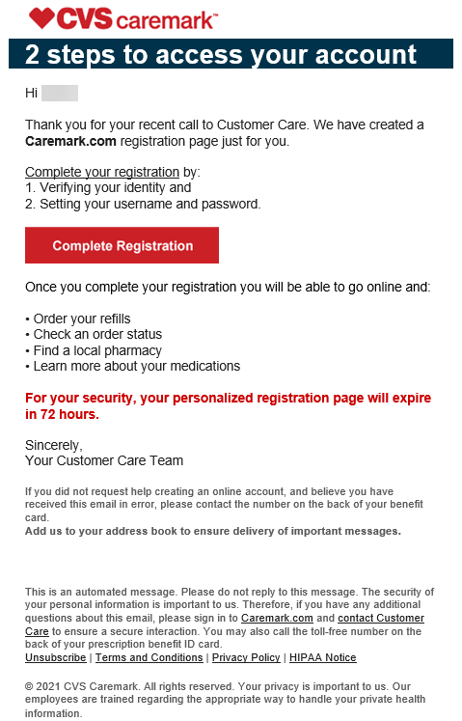

**Registration Confirmation**

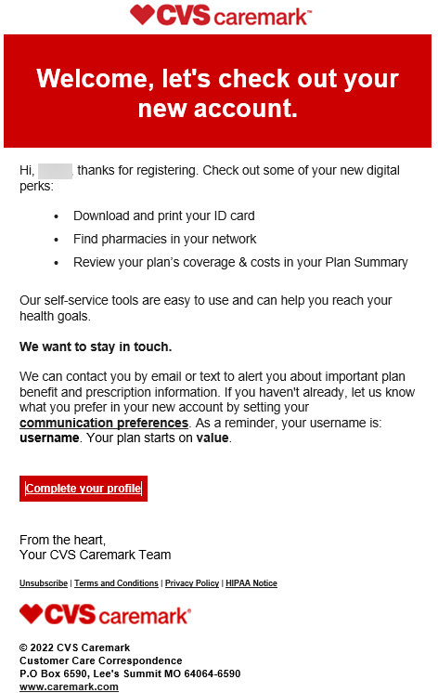

Top of the Document

|  |
| --- |
| Participant Hold |

**Participant Hold Example:**

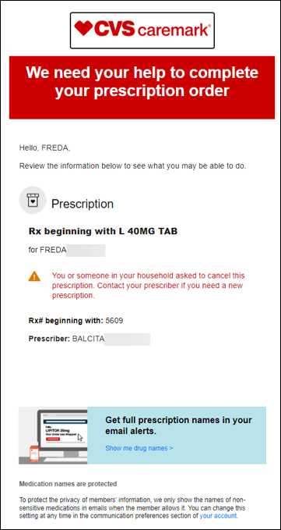

|  |
| --- |
| Multifactor Verification Code Request |

**Multifactor Verification Code Request Example:**

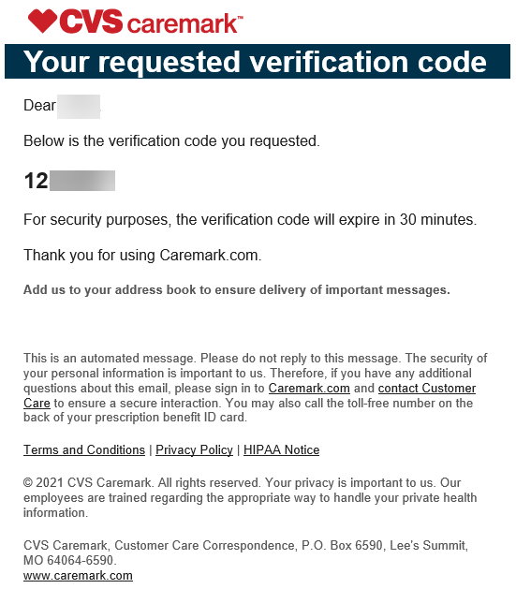

Top of the Document

|  |
| --- |
| Password Changed (Forgot Password) |

**Password Changed Example:**

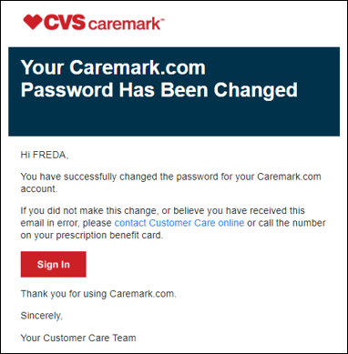

|  |
| --- |
| Username Retrieved (Forgot Username) |

**Username Retrieved Example:**

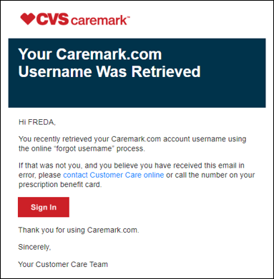

Top of the Document

|  |
| --- |
| Refill Available Alert |

**Refill Available Alert Examples:**

**Refill Available – Initial Alert**

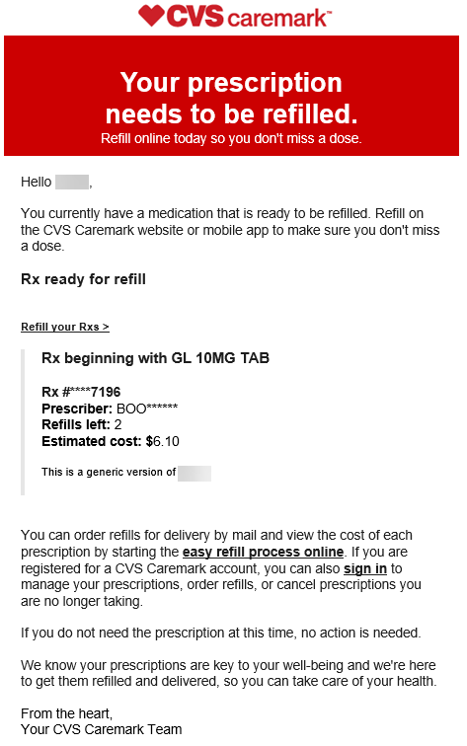

**Refill Available / Reminder Alert**

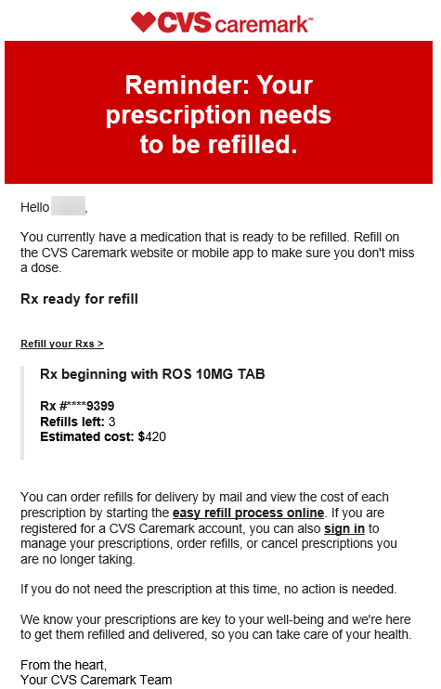

**Refill Available – Final Alert**

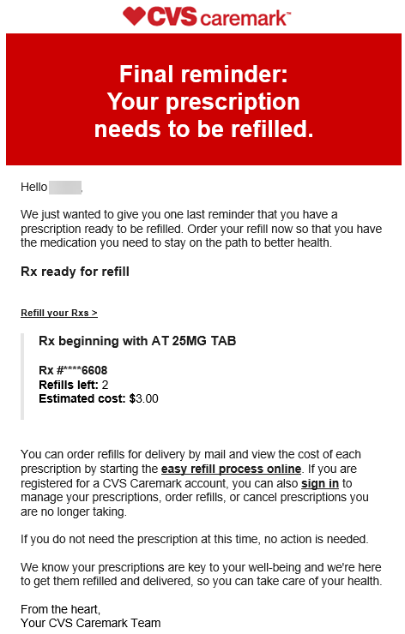

Top of the Document

|  |
| --- |
| Prescription about to Expire / Expired-Renew Rx |

**Prescription about to Expire**

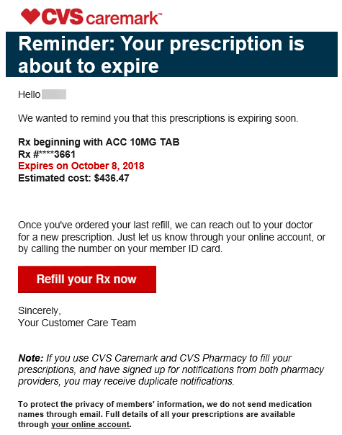

**Prescription Expired – Renew Rx**

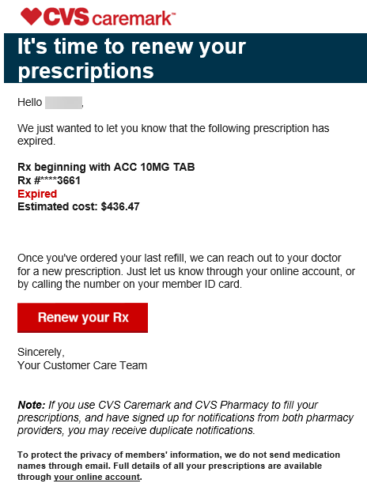

Top of the Document

|  |
| --- |
| Automatic Refill In Progress |

**Automatic Refill In Progress Example:**

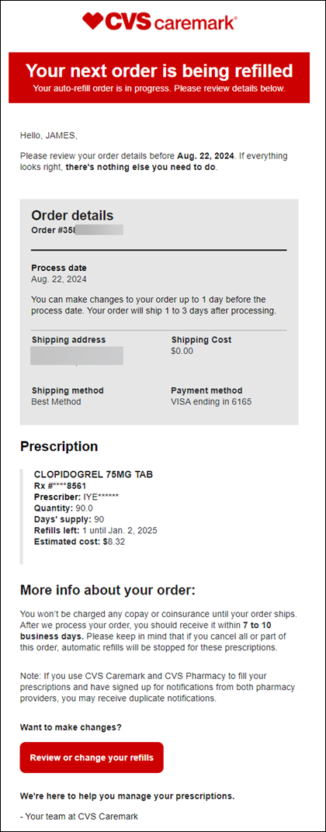

Top of the Document

|  |
| --- |
| Prescription Removed from Auto Refill/Renewal |

**Rx Removed from Automatic Refill/Renewal Example:**

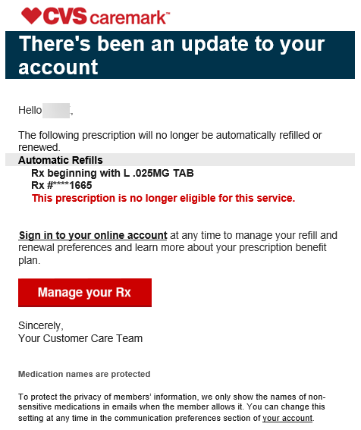

Top of the Document

|  |
| --- |
| Enrolling in Automatic Refills |

**Enrolling in Automatic Refill Example:**

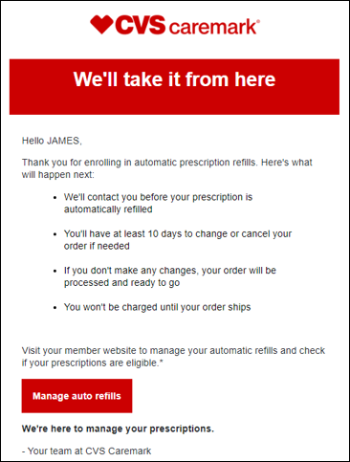

Top of the Document

|  |
| --- |
| Rx Savings Opportunities |

**Rx Savings Opportunities Example:**

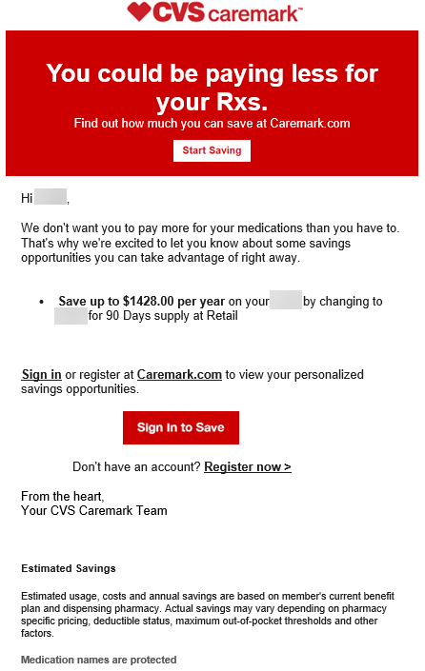

Top of the Document

|  |
| --- |
| Shipping Delay Confirmation |

**Shipping Delay Confirmation Example:**

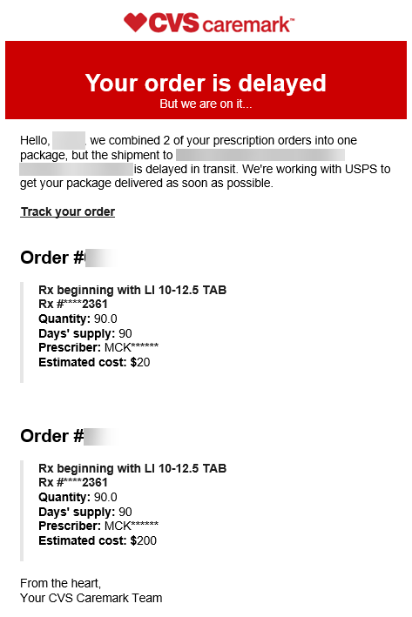

Top of the Document

|  |
| --- |
| Zero Refills Remain |

**Zero Refills Remain Examples:**

**Zero Refills – Initial Alert**

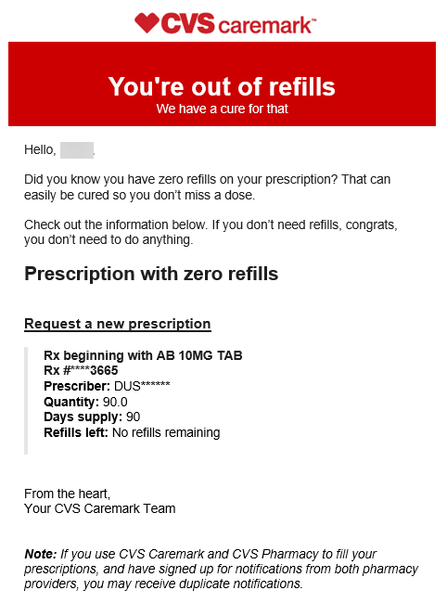

**Zero Refills – Reminder Alert**

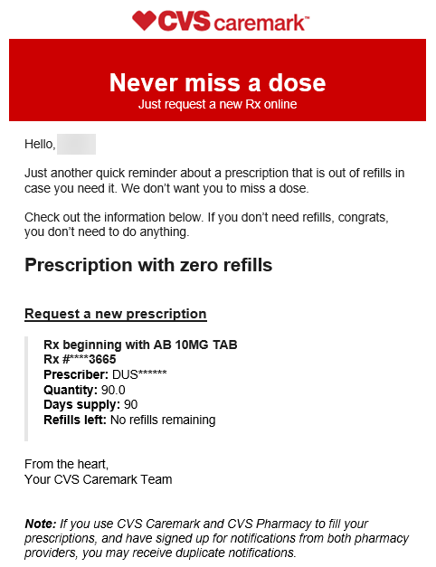

Top of the Document

|  |
| --- |
| Related Document |

**Parent Document:** Caremark.com - CMP Alert Messages Sent via Secure Message, Email, and Text (1 Way and 2 Way SMS)

Not To Be Reproduced Or Disclosed to Others Without Prior Written Approval

**ELECTRONIC DATA = OFFICIAL VERSION / PAPER COPY = INFORMATIONAL ONLY**